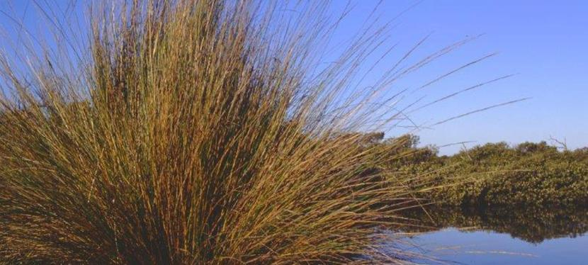

Regional Flora
The energy system that supports life in Western Port is based on photosynthetic plants. Without these plants, there would be no food chain and Western Port could not sustain its diverse ecosystems and biodiversity.

These plants also play a vital role in stabilizing coast lines and mud flats and hence influence the water quality within the bay.

Similarly, the quality of the terrestrial ecosystems and the stability of the landscape and hence the quality of water flowing into Western Port is dependent on healthy and sustainable terrestrial plant communities.

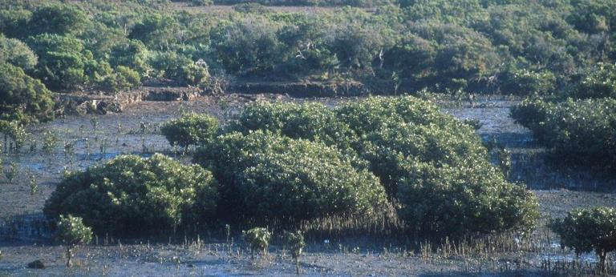

The WPSP gives its priority attention to the preservation and restoration of marine and coastal plant communites, and in particular the seagrasses, mangroves and saltmarshes.

In the catchment, the WPSP fully supports the actions of the Landcare movement on private land and the efforts of Friends Groups and Authorities on public lands, to achieve sustainable landscapes by protecting and restoring native plant communities and practicing sustainable farming land management practices.

